Name __________________ JMJ Date ___________
Period _________________ Physical Science

Scientists Chart

Scientist | Discovery/Belief | How?? | Model
 |  |  | 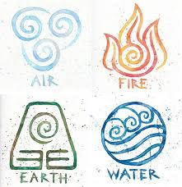
James Chadwick |  | ---------------------
 |  | The Gold Foil experiment | Apple
-Discovered the electron
-There must be a positive sphere with electrons in it
 |  |  | Circular orbits around the nucleus of an atom
Democritus
 | Believed Democritus’ idea | Used further scientific advancements | -----------------
Gilbert Lewis

